Assignment #14 Forecasting by Joshua Troup

Create a well formatted time plot of the data.

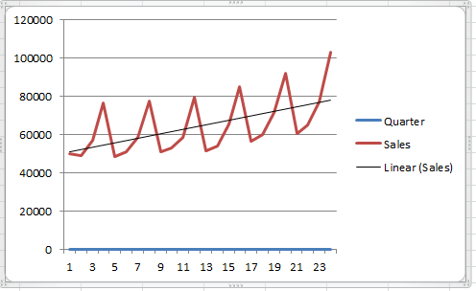

Which of the four components (level, trend, seasonality, noise) seem to be present in

this series? (this is just for you to develop an analytical mindset)

**Level, Trend, and Seasonality seem to be present in this series.**

Submit your Training Data plot of Actual vs Forecast

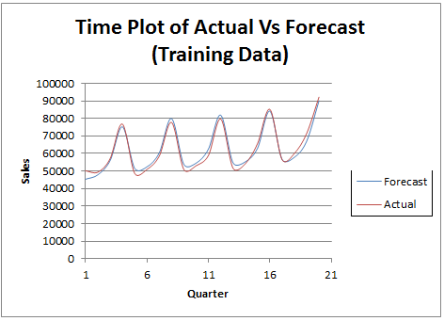

c) Present your forecasts for the validation set (Quarters 21 -24) from the above

XLMiner output.

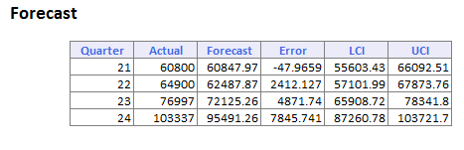

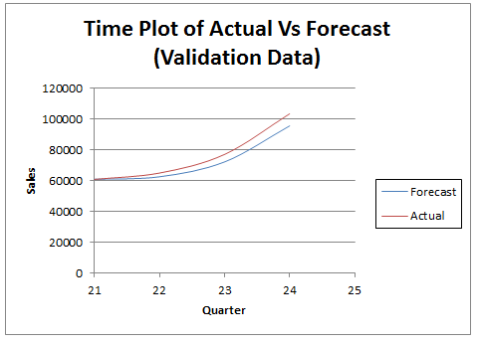

d) Compute the MAPE values for the forecasts of quarters 21 and 22 for each of the two models (regression and exponential smoothing).

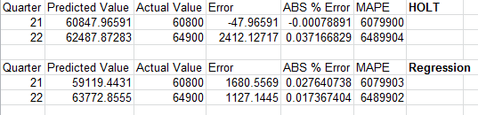

e) Which model is more suitable? Now, you can use the Training data forecast plots as well as forecast error plots for both the regression and Holt Winters exponential smoothing. Using all the information thus far, which model is more suitable for forecasting quarters 21 and 22?

**Both algorithms seem suitable for the data set. The MAPE for both HOLT and Regression are almost identical. The forecast plots and error plots are similar as well.**